IW Express API Documentation V 2.5

Environment - Development
Table of Contents
API #1: Consignment Creation 3
API #2: Shipping Label 4
API #3: Consignment Creation with Shipping Label 6
API #4: Consignment Tracking 9
Client Status Update Webhook 10

API #1: Consignment Creation

API URL: https://dev-b2b.iwexpress.com:5001/iwexpress/iwe-integration-service/softdata/upload
Request Type: POST
Input Authorization: Basic $2a$10$qWHNeBhu4FCGoJfuv2XVbO9Yq4QBUwGSvNM0bGpYUVc3iY8jXsJwO
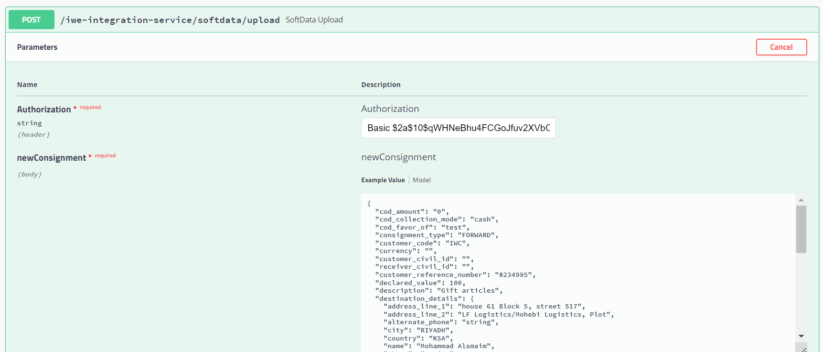
Request Payload

Response with <Consignment Reference Number>

SAMPLE REQUEST
{
"cod_amount": "100",
"currency": "SAR",
"cod_collection_mode": "cash", "cod_favor_of": "test", "consignment_type": "FORWARD", "customer_code": "IWC", "customer_reference_number": "296163865",
"customer_civil_id": "23333333",
"receiver_civil_id": "466655557",
"declared_value": 100, "description": "Gift", "destination_details": {
"address_line_1": "house 61 Block 5, street 517", "address_line_2": "LF Logistics/Mohebi Logistics, Plot", "alternate_phone": "string",
"city": "Kuwait",
"country": "Kuwait", "name": "الصميم محمد", "phone": "string",
"pincode": "91710",
"state": "string"
},
"dimension_unit": "CM", "height": "5",
"is_risk_surcharge_applicable": true,

"length": "10", "load_type": "DOCUMENT", "notes": "test", "num_pieces": 10, "origin_details": {
"address_line_1": "LF Logistics/Mohebi Logistics, Plot", "address_line_2": "Mohebi Logistics; Plot WT01 & WT04", "alternate_phone": "",
"city": "Dubai",
"country": "UAE", "name": " الكوخ مجموعة",
"phone": "97101606811863",
"pincode": "8005",
"state": "DUBAI"
},
"pieces_detail": [
{
"declared_value": 100, "description": "Gift", "height": 100,
"length": 500,
"weight": 1.2,
"width": 200
}
],
"service_type_id": "PREMIUM", "weight": 1.2,
"weight_unit": "KG",
"width": "200"
}

API #2: Shipping Label

API URL:

https://dev-b2b.iwexpress.com:5001/iwexpress/iwe-integration-service/{referenceNumber}/shippingLabel

Sample Request:

https://dev-b2b.iwexpress.com:5001/iwexpress/iwe-integration-service/IW00001/shippingLabel

Request Type: GET

Input Authorization as below.

Basic $2a$10$qWHNeBhu4FCGoJfuv2XVbO9Yq4QBUwGSvNM0bGpYUVc3iY8jXsJwO
Response: <pdf file>

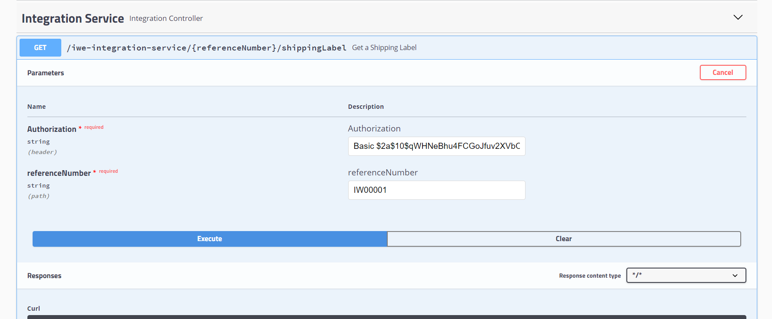

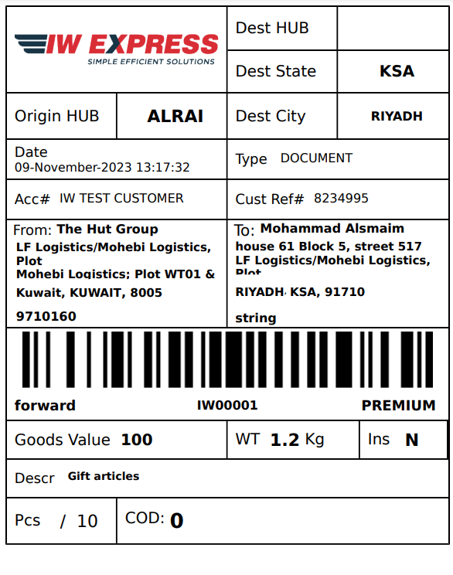

API #3: Consignment Creation with Shipping Label generation

API URL: https://dev-b2b.iwexpress.com:5001/iwexpress/iwe-integration-service/softdata/upload/v2
Request Type: POST
Input Authorization: Basic $2a$10$qWHNeBhu4FCGoJfuv2XVbO9Yq4QBUwGSvNM0bGpYUVc3iY8jXsJwO

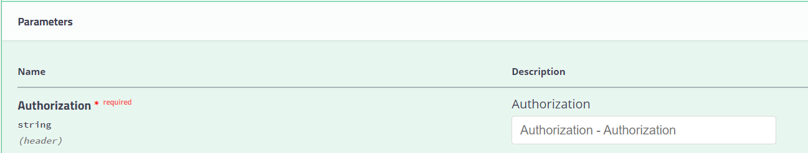

Order Details as like below structure (JSON Provided)
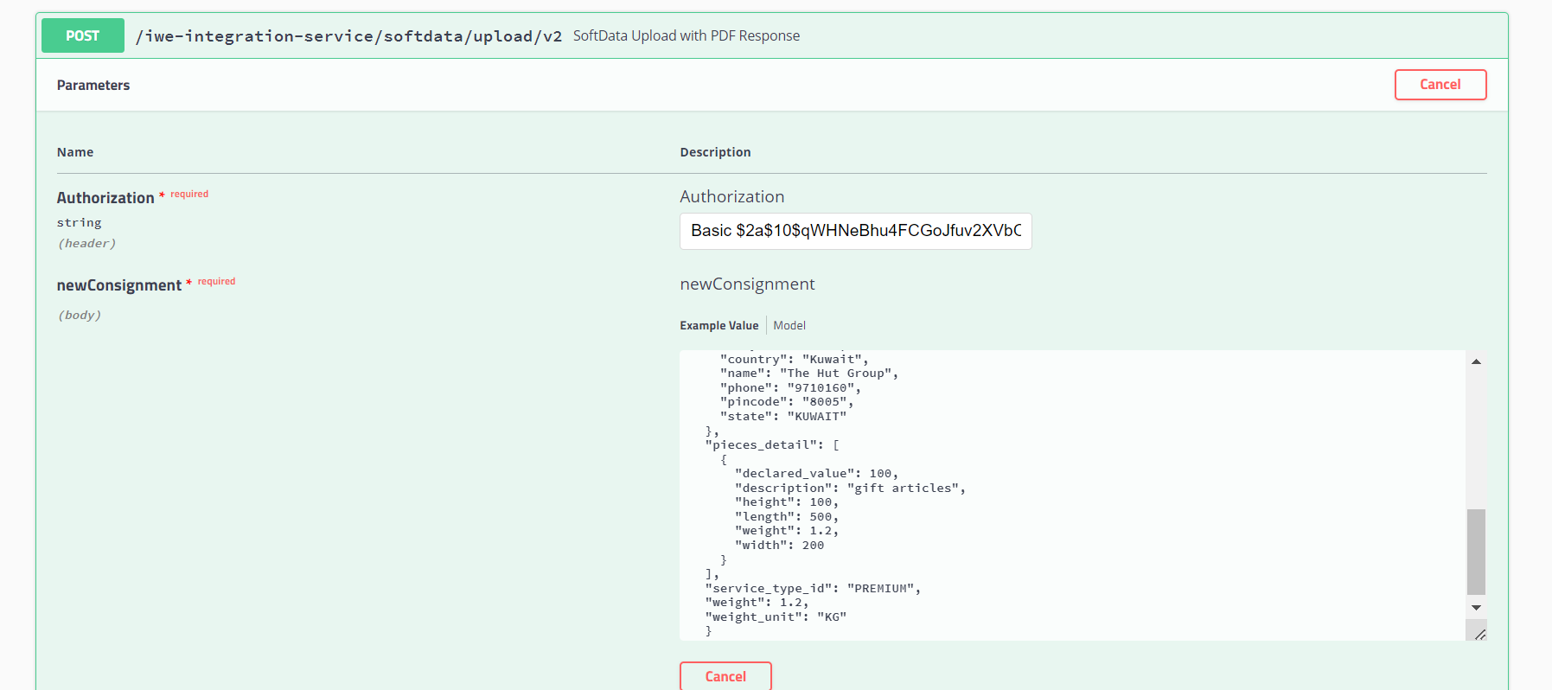

Request JSON
{
"cod_amount": "string",
"currency": "string",
"cod_collection_mode": "string", "cod_favor_of": "string", "consignment_type": "string", "customer_code": "IWC", "customer_reference_number": " string",
"customer_civil_id": "string",
"receiver_civil_id": "string",
"declared_value": 0, "description": "string", "destination_details": {
"address_line_1": "string", "address_line_2": "string", "alternate_phone": "string", "city": "string",
"country": "string",
"name": "string",
"phone": "string",
"pincode": "string",
"state": "string"
},
"dimension_unit": "string", "height": "string", "is_risk_surcharge_applicable": true, "length": "string",
"load_type": "string", "notes": "string", "num_pieces": 0, "origin_details": {
"address_line_1": "string", "address_line_2": "string", "alternate_phone": "string", "city": "string",
"country": "string",
"name": "string",
"phone": "string",
"pincode": "string",
"state": "string"
},
"pieces_detail": [
{
"declared_value": 0, "description": "string", "height": 0,
"length": 0,
"weight": 0,
"width": 0
}
],
"service_type_id": "string", "weight": 0,
"weight_unit": "string", "width": "string"
}

SAMPLE REQUEST
{
"cod_amount": "100",
"currency": "SAR",
"cod_collection_mode": "cash", "cod_favor_of": "test", "consignment_type": "FORWARD", "customer_code": "IWC", "customer_reference_number": "296163865",
"customer_civil_id": "23333333",
"receiver_civil_id": "466655557",
"declared_value": 100, "description": "Gift", "destination_details": {
"address_line_1": "house 61 Block 5, street 517", "address_line_2": "LF Logistics/Mohebi Logistics, Plot", "alternate_phone": "string",
"city": "Kuwait",
"country": "Kuwait", "name": "الصميم محمد", "phone": "string",
"pincode": "91710",
"state": "string"
},
"dimension_unit": "CM", "height": "5",
"is_risk_surcharge_applicable": true,

"length": "10", "load_type": "DOCUMENT", "notes": "test", "num_pieces": 10, "origin_details": {
"address_line_1": "LF Logistics/Mohebi Logistics, Plot", "address_line_2": "Mohebi Logistics; Plot WT01 & WT04", "alternate_phone": "",
"city": "Dubai",
"country": "UAE", "name": " الكوخ مجموعة",
"phone": "97101606811863",
"pincode": "8005",
"state": "DUBAI"
},
"pieces_detail": [
{
"declared_value": 100, "description": "Gift", "height": 100,
"length": 500,
"weight": 1.2,
"width": 200
}
],
"service_type_id": "PREMIUM", "weight": 1.2,
"weight_unit": "KG",
"width": "200"
}

Response JSON: [PDF Stream response]



API #4: Consignment Tracking

API URL:
https://dev-b2b.iwexpress.com:5001/iwexpress/iwe-integration-service/tracking/{referenceNumber}/shipment
referenceNumber: [consignment reference number]
Request Type: GET
Authorization: Basic $2a$10$qWHNeBhu4FCGoJfuv2XVbO9Yq4QBUwGSvNM0bGpYUVc3iY8jXsJwO
Sample Request:
https://dev-b2b.iwexpress.com:5001/iwexpress/iwe-integration-service/tracking/IW00001/shipment

Response JSON: [Consignment Tracking details]

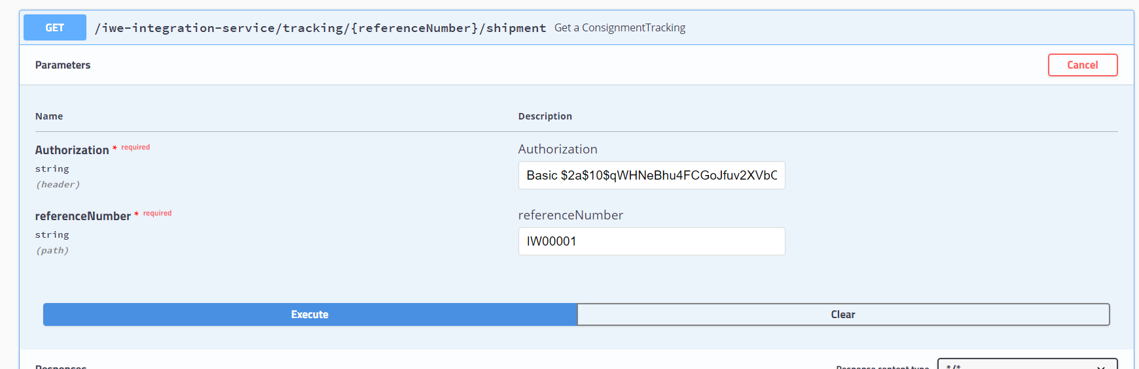
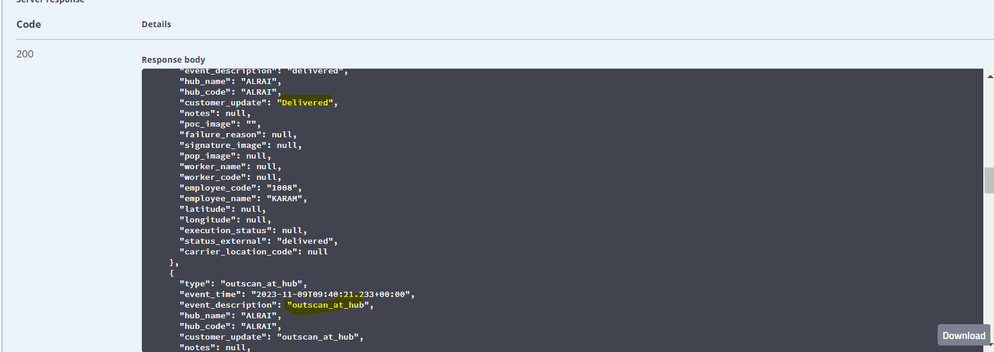

Client Status Update Webhook

Domestic Shipments

Following are the list of events (with description) supported which is provided in the key type as seen in the payload. Supported Events
1. accept - When the consignment is out for delivery
2. added_to_bag - When the consignment is added to a bag in a trip
3. assigned_for_delivery - When an consignment is assigned to any rider for delivery
4. assigned_to_hub - When task is assigned to rider for delivery
5. attempted - When a consignment is undelivered
6. bag_received - When bag is unloaded from the trip
7. cancelled - When a consignment is cancelled
8. consignment_verification - When consignment Verification is done
9. customs_clearance_completed - When the consignment is cleared from customs
10. delay_at_airport - When the consignment is at airport and not processed due to some reasons
11. delivered - When a consignment is delivered
12. delivery_pod - When the 3PL send s POD separately post the delivered event (Select this event is you ar using delivered event)
13. deps_exception - When the consignment is received as Damaged, Excess, Shortage or Pilferage
14. exception - When a event is received that does not belong to other events in the list
15. handed_in_customs_clearance - When the consignment is handed to the customs at airport
16. handover_courier_partner - When the consignment is handed over to the 3PL
17. inscan_at_hub - When a consignment is inscanned at any hub
18. intransittohub - When a consignment is part of any mid mile hub and the mid mile trip is ongoing
19. lost - When a consignment is lost
20. not_picked_up - When the consignment is not picked up
21. on_hold - When consignment is put on hold for some reasons
22. out_for_pickup - When the delivery executive is out for pickup
23. out_for_store_pickup - When the delivery executive is out for pickup (PUDO Flow only)
24. outscan_at_hub - When a consignment is marked as outscan from a hub
25. pickup_awaited - When the delivery executive is yet to be assigned for pickup
26. pickup_completed - When the pickup is completed by the delivery executive
27. pickup_scheduled - When the pickup has been scheduled for a consignment
28. reachedathub - When the consignment reached the destination hub (generally the last mile hub)
29. release_on_hold - When a consignment is released from hold
30. reschedule - When the consignment pickup or delivery is rescheduled
31. returned_at_hub - When the consignment is received at hub post a delivery attempt
32. revert_from_delivered - When a consignment is revoked from delivery for exceptional reasons (Aplicable from CRM)
33. revoke_rto - When RTO is revoked for exceptional reasons (Applicable from CRM)
34. rto - When the consignment is marked as RTO
35. rto_attempted - When the consignment is undelivered in a RTO journey
36. rto_delivered - When the consignment is delivered in a RTO journey
37. rto_in_transit - When the consignment is in transit in a RTO journey
38. rto_initiated - When the consignment is marked as RTO (this is a preferred over the event rto)
39. rto_inscan_at_hub - When the consignment is inscanned at hub in a RTO journey
40. rto_outfordelivery - When the consignment is out for delivery in a RTO Journey
41. seized - When the consignment is seized by an external party before being delivered
42. shelved - When the consignment is shelved for some reasons
43. softdata_upload - When consignment is created in Shipsy system
44. vehicle_arrived - When the vehicle has arrived to a different hub in a middle mile trip

Cross Border Shipments

Following are the list of events (with description) supported which is provided in the key type as seen in the payload.
Supported Events
1. on_hold
2. release_on_hold
3. pickup_completed
4. delivered
5. attempted
6. rto
7. cancel
8. shipment_clear_successfully
9. intransit_to_hub
10. reached_at_hub
11. inscan_at_hub
12. accept

